EXERCISE 4.3

**NCERT Solutions for Class 10 Chapter 4-**

**Quadratic Equations**

EXAMBUDDY

Question 1:

Find the nature of the roots of the following quadratic equations. If the real roots exist, find them:  
(i) 2x² -3x + 5 = 0  
(ii) 3x2 – 4√3x + 4 = 0  
(iii) 2x2-6x + 3 = 0

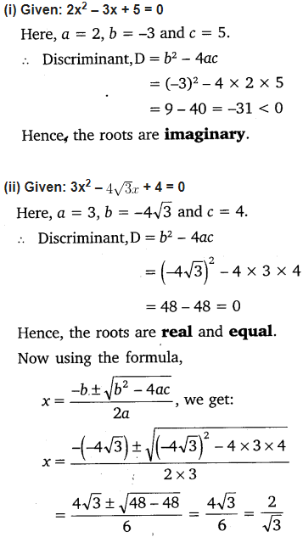**Solution:**

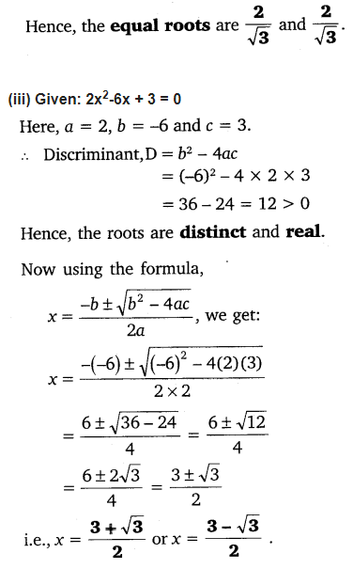

Question 2:

Find the values of k for each of the following quadratic equations, so that they have two equal roots.

1. 2x2 + kx + 3 = 0
2. kx (x – 2) + 6 = 0

Solution:

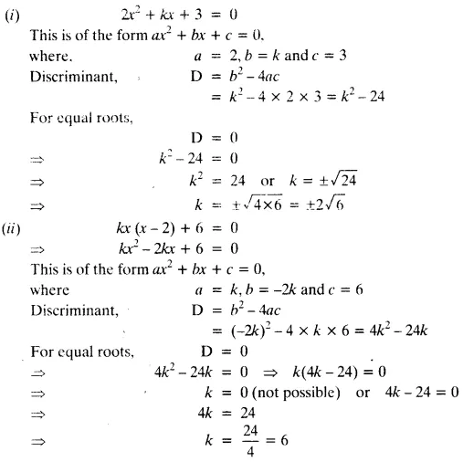

Question 3:

Is it possible to design a rectangular mango grove whose length is twice its breadth, and the area is 800 m2? If so, find its length and breadth.

Solution:

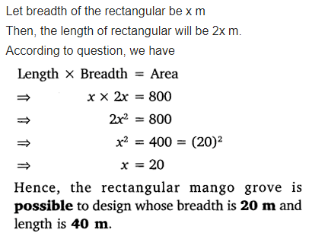

Question 4:

Is the following situation possible? If so, determine their present ages.  
The sum of the ages of two friends is 20 years. Four years ago, the product of their ages in years was 48.

Solution:

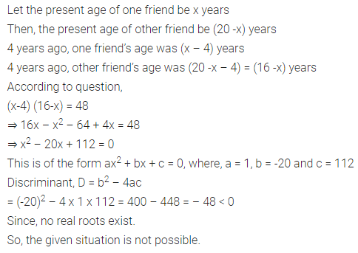

Question 5:

Is it possible to design a rectangular park of perimeter 80 m and area 400 m2? If so, find its length and breadth.

Solution:

